**Project 3A – Problem and Description**

In this portion of Project 3 the task was to input an arithmetic expression (1), convert it to postfix and print the postfix (2). It was also meant to be repeated 5 times.

1. This task was accomplished by asking the using to enter in the expression to be translated to postfix expression:

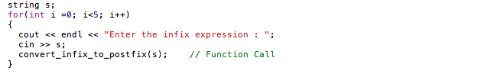

1. Then declare a space for the variable on the stack and loop through the expression placing the values of the expression onto the stack. There was a specific function for dealing with operators. After taking care of the operators it pops the expression to the screen in the order that it appears on the stack.

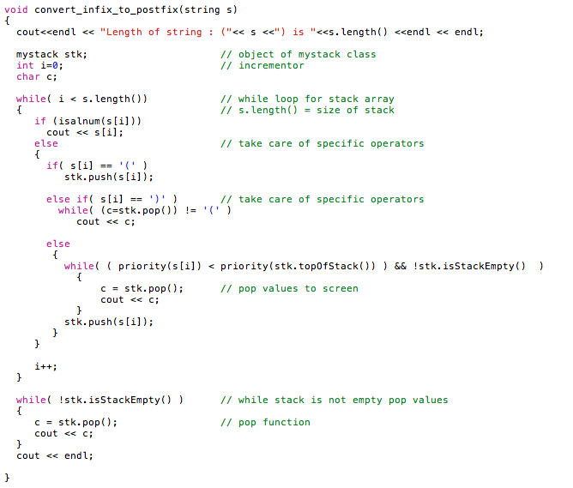

**Project 3A – Input and Output**

Enter the infix expression : 3*X+(Y-12)-Z

Length of string : (3*X+(Y-12)-Z) is 12

3X*Y12-Z-+

Enter the infix expression : 5+9+7

Length of string : (5+9+7) is 5

597++

Enter the infix expression : (7+(3*5))-4

Length of string : ((7+(3*5))-4) is 11

735*+4-

Enter the infix expression : 3-5+7*4

Length of string : (3-5+7*4) is 7

3574*+-

Enter the infix expression : (2+3)*7

Length of string : ((2+3)*7) is 7

23+7*

**InfixtoPostfix.cpp**

